**LAB 8**

2021112010

Vedansh Agrawal

**Part A:**

1. Given are the DTFTs of an ideal filter and after it was windowed,

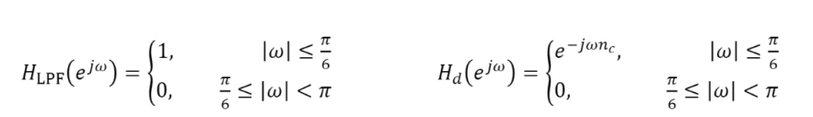

To obtain the windowed FIR filter, we need to find h[n] of the ideal filter which will come out to be a sinc function after which we window it with a size of 51 samples to obtain a part of the sinc function.

1. Here we take the 1001-point DFT of the above impulse function and plot the impulse function along with the magnitude and phase response of the DFT where the magnitude response is in decibel scale. We can notice how this is also a low pass filter with a lot of ripples at the pass and stop band.

As we can see from the plots, the phase increases and decreases linearly with respect to the frequency.

1. Now instead of using a rectangular window, we do the same thing as above but with another window called Blackman window, and the plots will be as followed,

1. Now comparing the results of the both the filters, we can observe the Blackman window giving us a better shape. We see the Blackman window gives a clean window with less side lobes while the transition bandwidth is a little more than the rectangular window.
2. Now we implement our obtained filters to an input



Following is the input and outputs of both our filters,

We can see the ends of our outputs being attenuated which shows that they have been filtered. Both filters give almost the same output as their cutoff frequencies are better. Now we add some random noise to our input and then filter it. We will observe how our filter removes all the noise,

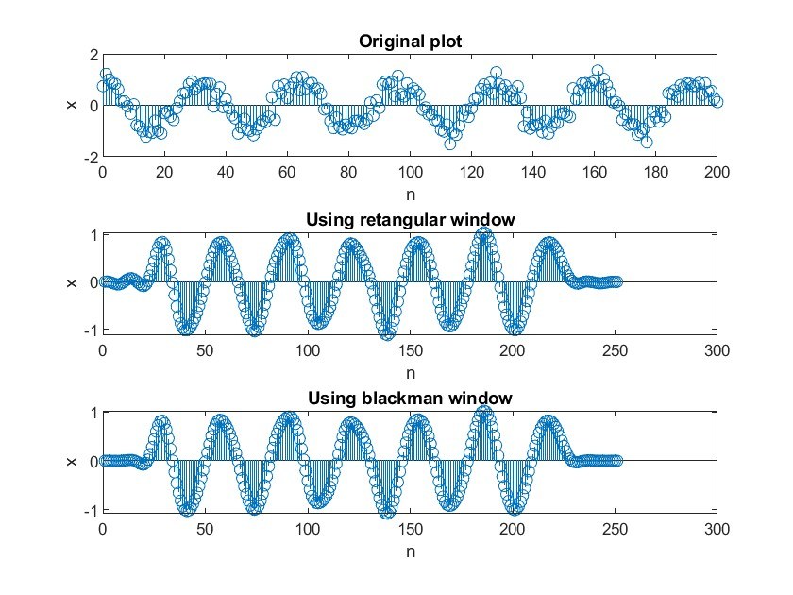

1. Now we change our filter from the first part as follows,



Now we plot this impulse response and the magnitude and phase plot of its DFT and following is our results,

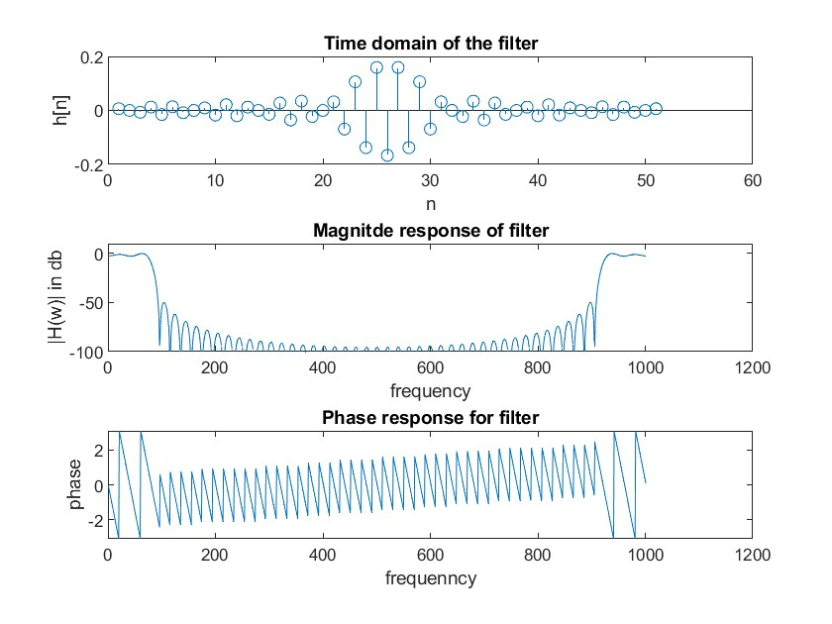

As we can observe from the plot above, it acts as a high pass filter.

**Part B:**

1. Here, we look at notch filters which have 2 zeros on the unit circle at ejwo so that it removes the frequencies at Wo from the frequency response of the input signal. Following will be the impulse response of the filter,

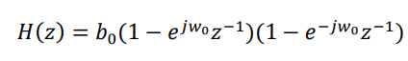

Where bo is chosen such that H(1) = 1. Now we plot the 2001 point frequency response using freqz() assuming wo is pi/4,

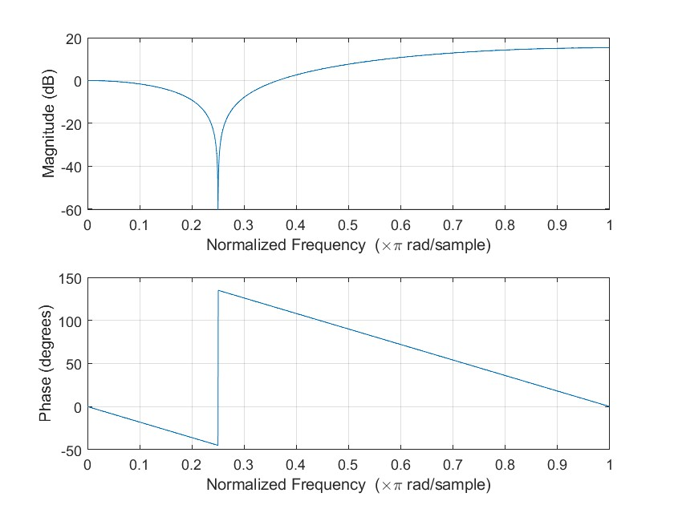

As we can see, this has one zero at Wo.

1. Alternately, along with the two zeros on the unit circle at 𝑒±𝑗𝜔0, we can additionally place two poles at 𝑟0 𝑒±𝑗𝜔0, where 𝑟0 < 1. This gives the system function

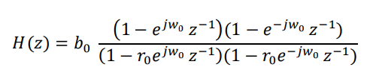

Again, by finding the frequency response of this, we obtain

We can see the magnitude response is more level.

1. The first filter does not have any poles which means it is summable always hence it is stable, and the ROC contains z = inf, which makes the first filter causal also.

The second filter has 2 poles inside the unit circle so the ROC includes the unit circle as well as z = inf, so this is also stable and causal.

1. Now we use fvtool() to visualise the different kind of plots for the above impulse responses for the given notch filters. The pictures of these will be included in the submission. Now we vary the value of ro in the above impulse response and notice the change in the filter,

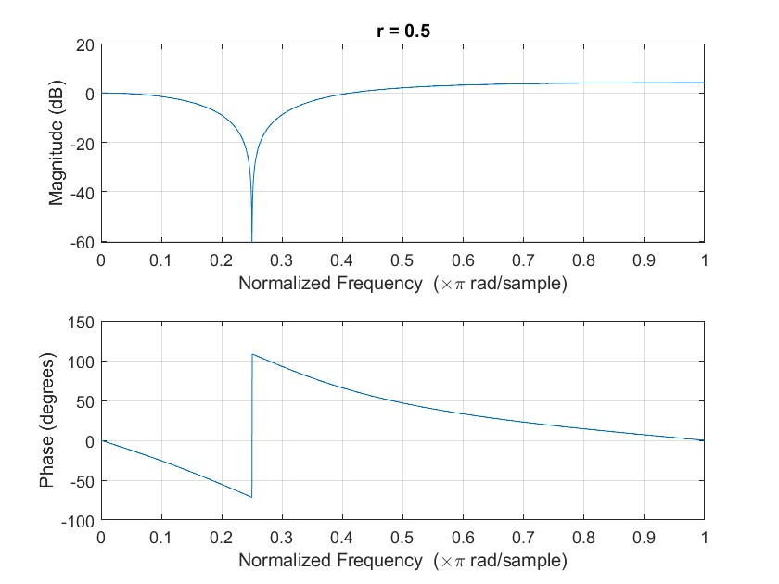

As we can see, the larger the value of ro is, the precision of our filter increases more.

1. Now we upload a sound file which is called handel, and we add a sinusoidal wave to create sound at frequency 1024Hz. Now we pass this signa through the 2 notch filters that we obtained, and we listen to the output and input. We can notice that the sound becomes more cleaner after filtering.
2. Following are the plots of the input and the output of the filters,

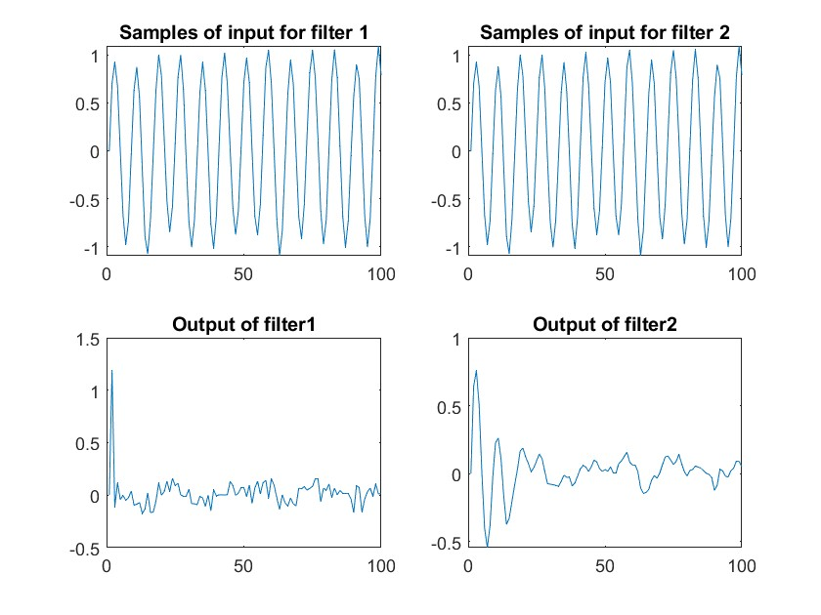

We see that output of filter 2 is more clean but its amplitude is less than our output of the first filter and this is expected as observed from the frequency response of both filters found before.

**Part C:**

1. Here we use the inbuilt filterDesigner on matlab to design filters. With the specifications of the filter given in PART A, a) we obtain the following filter,

This is like our filter obtained by windowing in Part A.

1. Here, we just go through all the type of plots that we are given in the interface like, phase plot, impulse response, pole zero plot, step response, etc. The images of his will be submitted on github.
2. Here, we design a equiripple filter with specifications as given in the lab manual and obtain the following filter,

As the name suggests and as we can observe, the ripples of the pass and stop band have almost the same size which is more desirable in a filter.

1. Now we change the method of making the filter to least-squares. We obtain the following filter,

We can notice the difference in the hight of the side lobes, in this filter, the hight decreases continuously.